

UNITEDWORLD INSTITUE OF TECHNOLOGY

(UIT)

Summative Assessment (SA)

Submitted BY

Patel Zalak Bipinkumar

(Enroll. No.: 20220701020)

**Course Code and Title:**

**21BSAI99E43 [Artificial Neural Networks]**

B.Sc. (Hons.) Computer Science

IV Semester – December – May 2024

**UIT**

March/April 2024

Contents

**INTRODUCTION** 3

PROJECT TITLE: 3

PROBLEM STATEMENT: 3

OBJECTIVE: 3

**APPROACH** 3

DATA COLLECTION: 3

PREPROCESSING: 5

MODEL ARCHITECTURE: 9

TRAINING: 10

FINE TUNING: 15

PROJECT IMPLEMENTATION: 17

CONCLUSION: 18

# 

# INTRODUCTION

PROJECT TITLE: Rice Leafs Disease Detection

## PROBLEM STATEMENT:

To improve Crop Yield is the main target of farmers but due to some diseases which exists in crops and leafs the yield of crop is affected. Which can be a great loss to farmers. Building an ANN model which can help recognize disease in crops can be helpful to farmers to cure it as early as possible. In some cases it is not possible to identify leaf infections with naked eyes in that cases this model can be beneficial to farmers which can accurately identify disease in Rice Leafs.

## OBJECTIVE:

Creating an ANN (Artificial Neural Network) model for rice leaf disease detection and diagnosis provides an enormous opportunity to transform agricultural methods. The goal of this research is to build an advanced artificial neural network (ANN) architecture that can precisely identify healthy leaves from diseased ones in images of rice leaves, including brown spot, blast, and bacterial blight. The model will be trained on an extensive set of labelled rice leaf photos. In addition, the artificial neural network (ANN) model will be real-time processing adjusted to facilitate rapid choices in the field. This project aims to provide farmers with an effective tool allowing early disease identification by utilizing ANN technology. This will allow for timely actions, which will eventually improve agricultural productivity and food security."

# APPROACH

## DATA COLLECTION:

Dataset for Rice Leafs Disease Detection is taken from Kaggle. Below is given the link for Train and Validation set of data which has total six types of disease classification which are healthy, brown spot, leaf blast, leaf scald, bacterial leaf blight and narrow brown spot, In given dataset there are 2100 training data in which each training category contains 350 images and there are 528 validation data images in which each validation category contains 88 images.

<https://www.kaggle.com/datasets/dedeikhsandwisaputra/rice-leafs-disease-dataset>

For testing the model on unseen data testing set from another dataset is taken from kaggle named rice leaf disease dataset. Which contains 6 categories of disease same as training and validation data.

<https://www.kaggle.com/datasets/raihan150146/rice-leaf-diseases-dataset\>

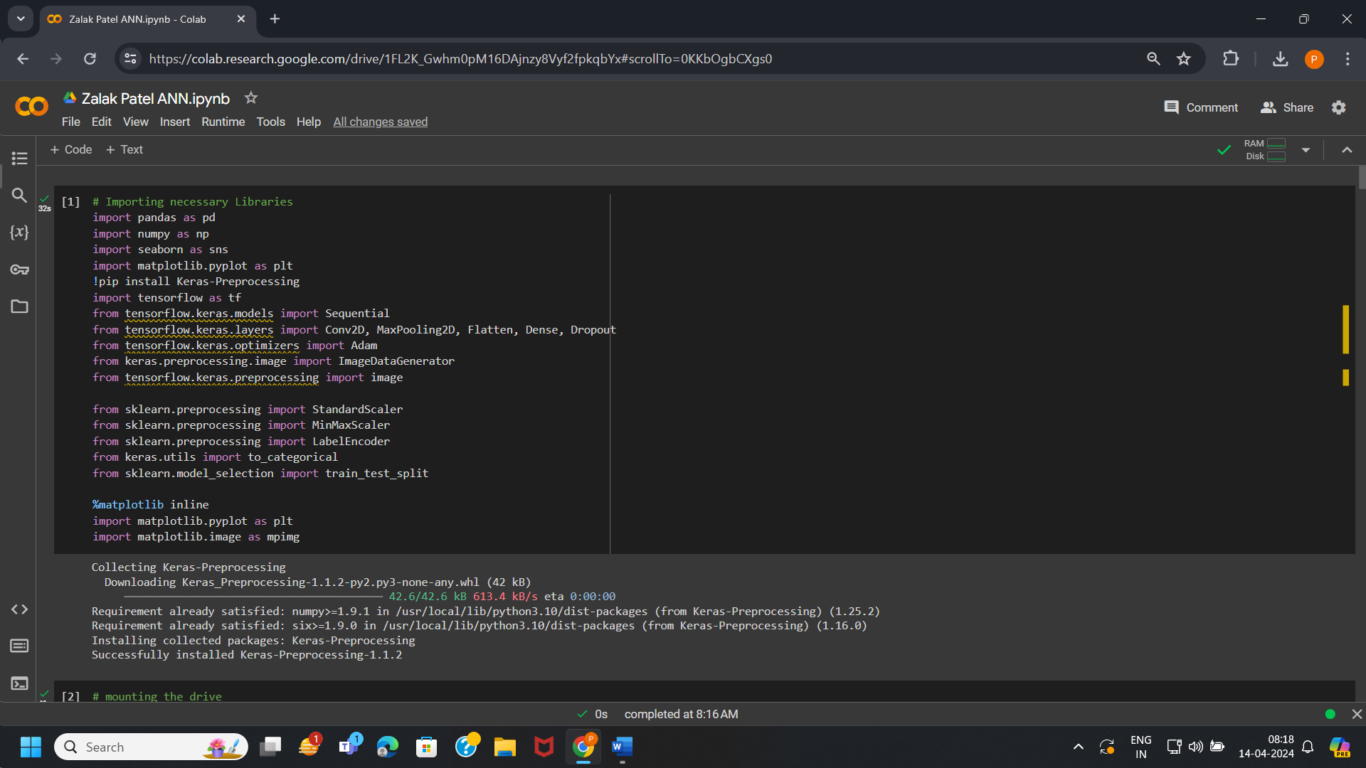

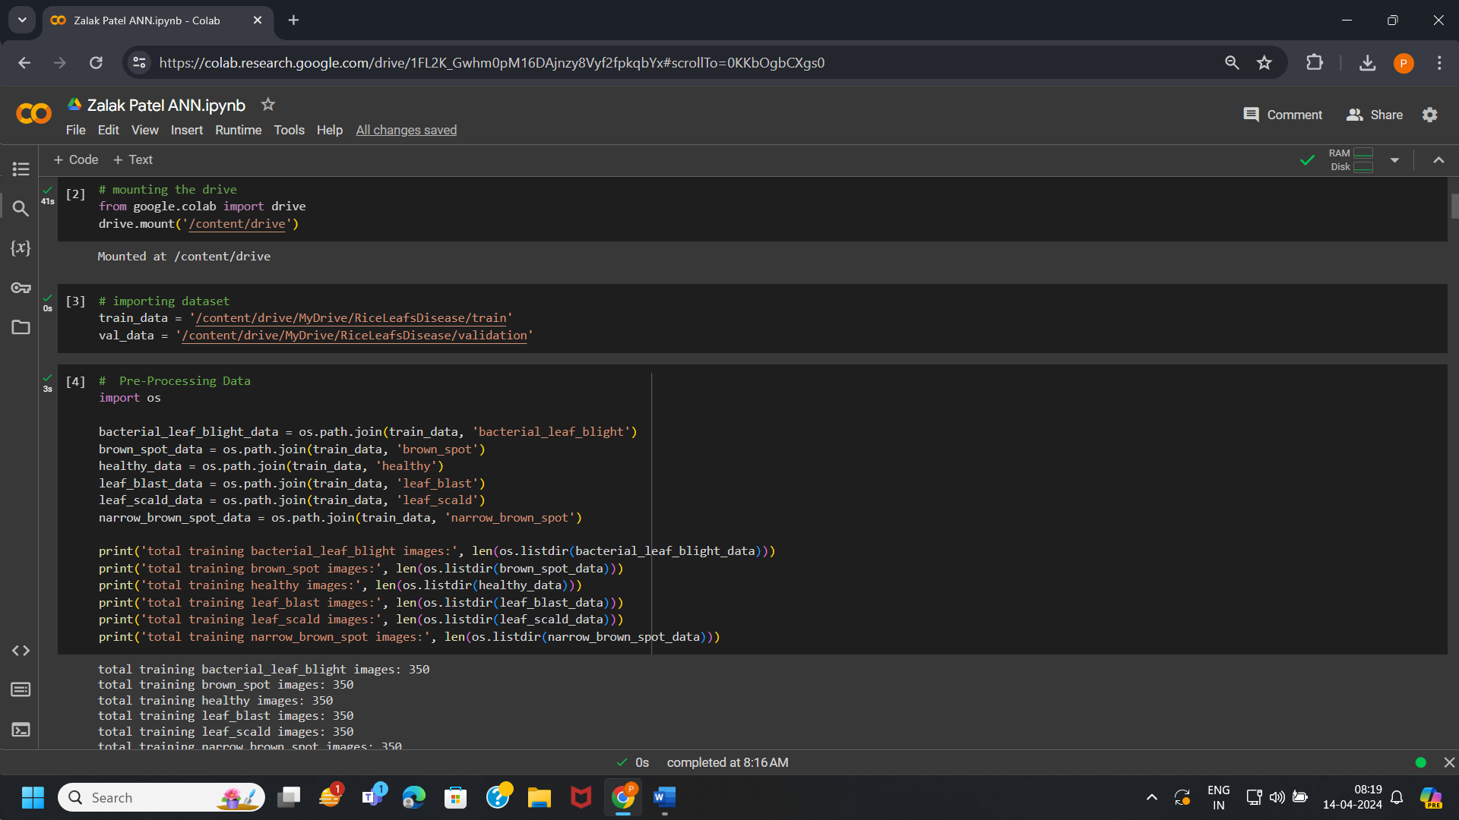

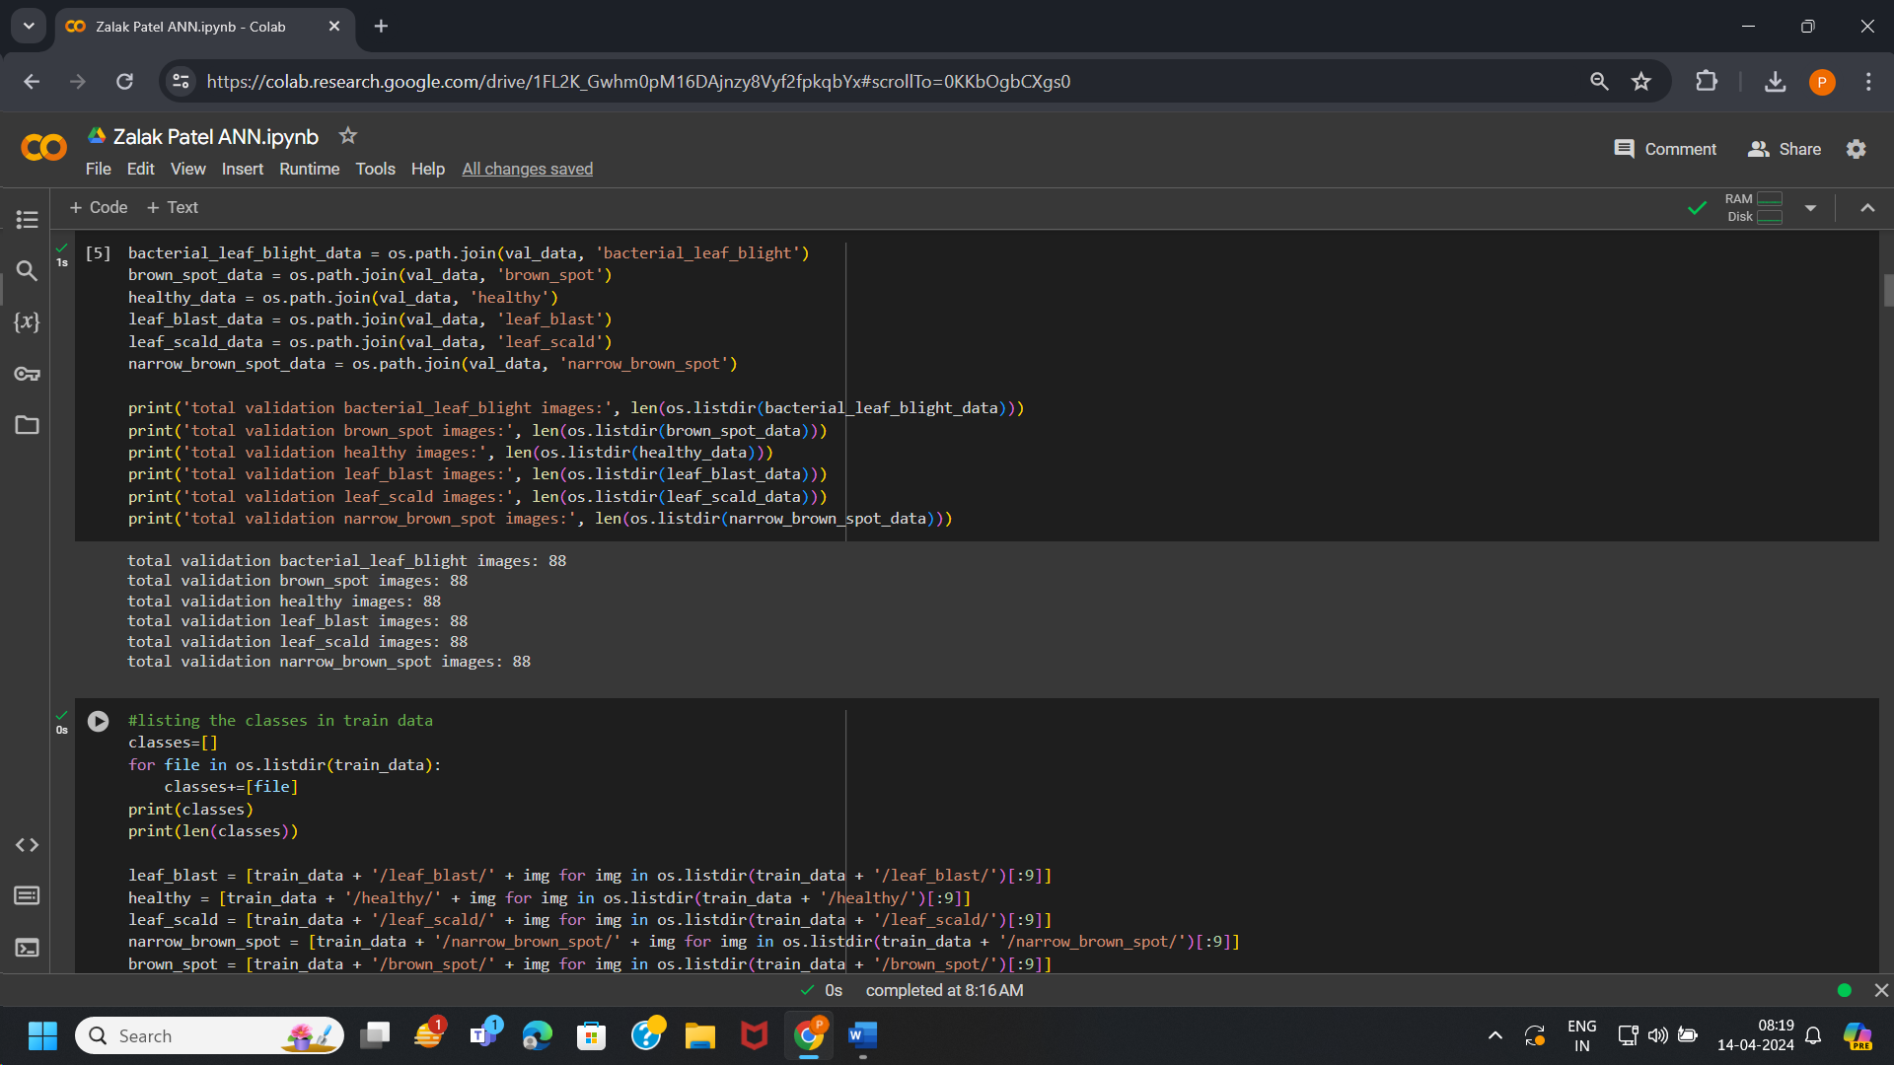

# PREPROCESSING:

In this part of the project we perform data cleaning, data visualization and enhancing data in a way which can train the mode more efficiently.

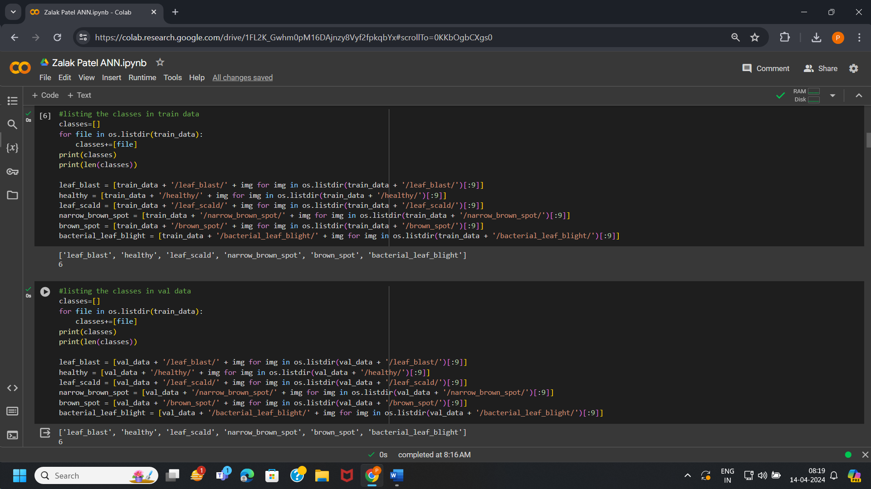

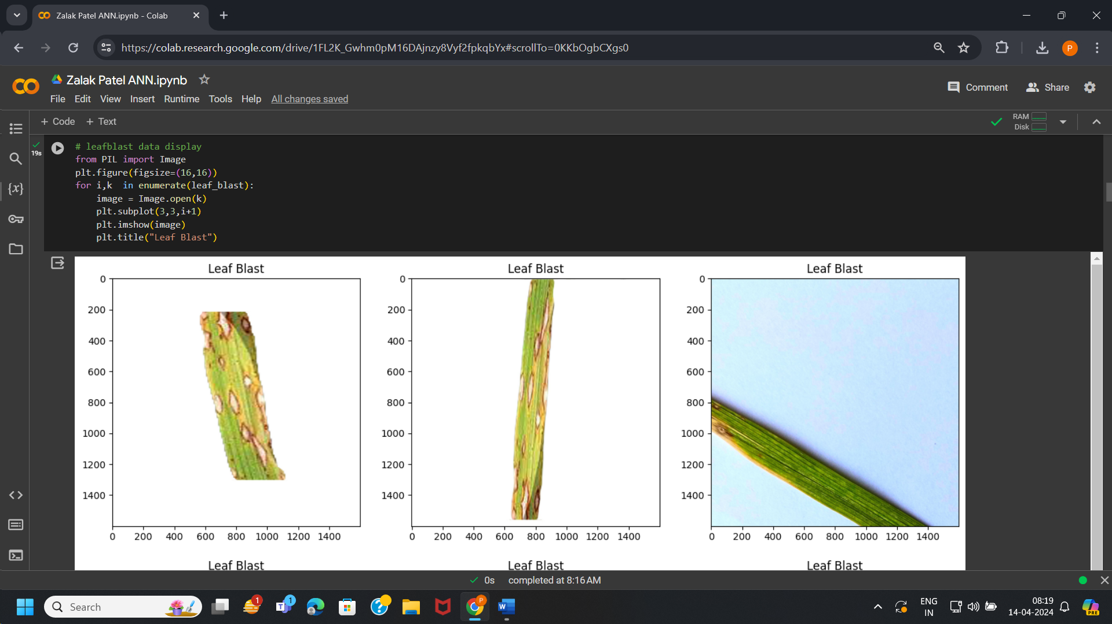

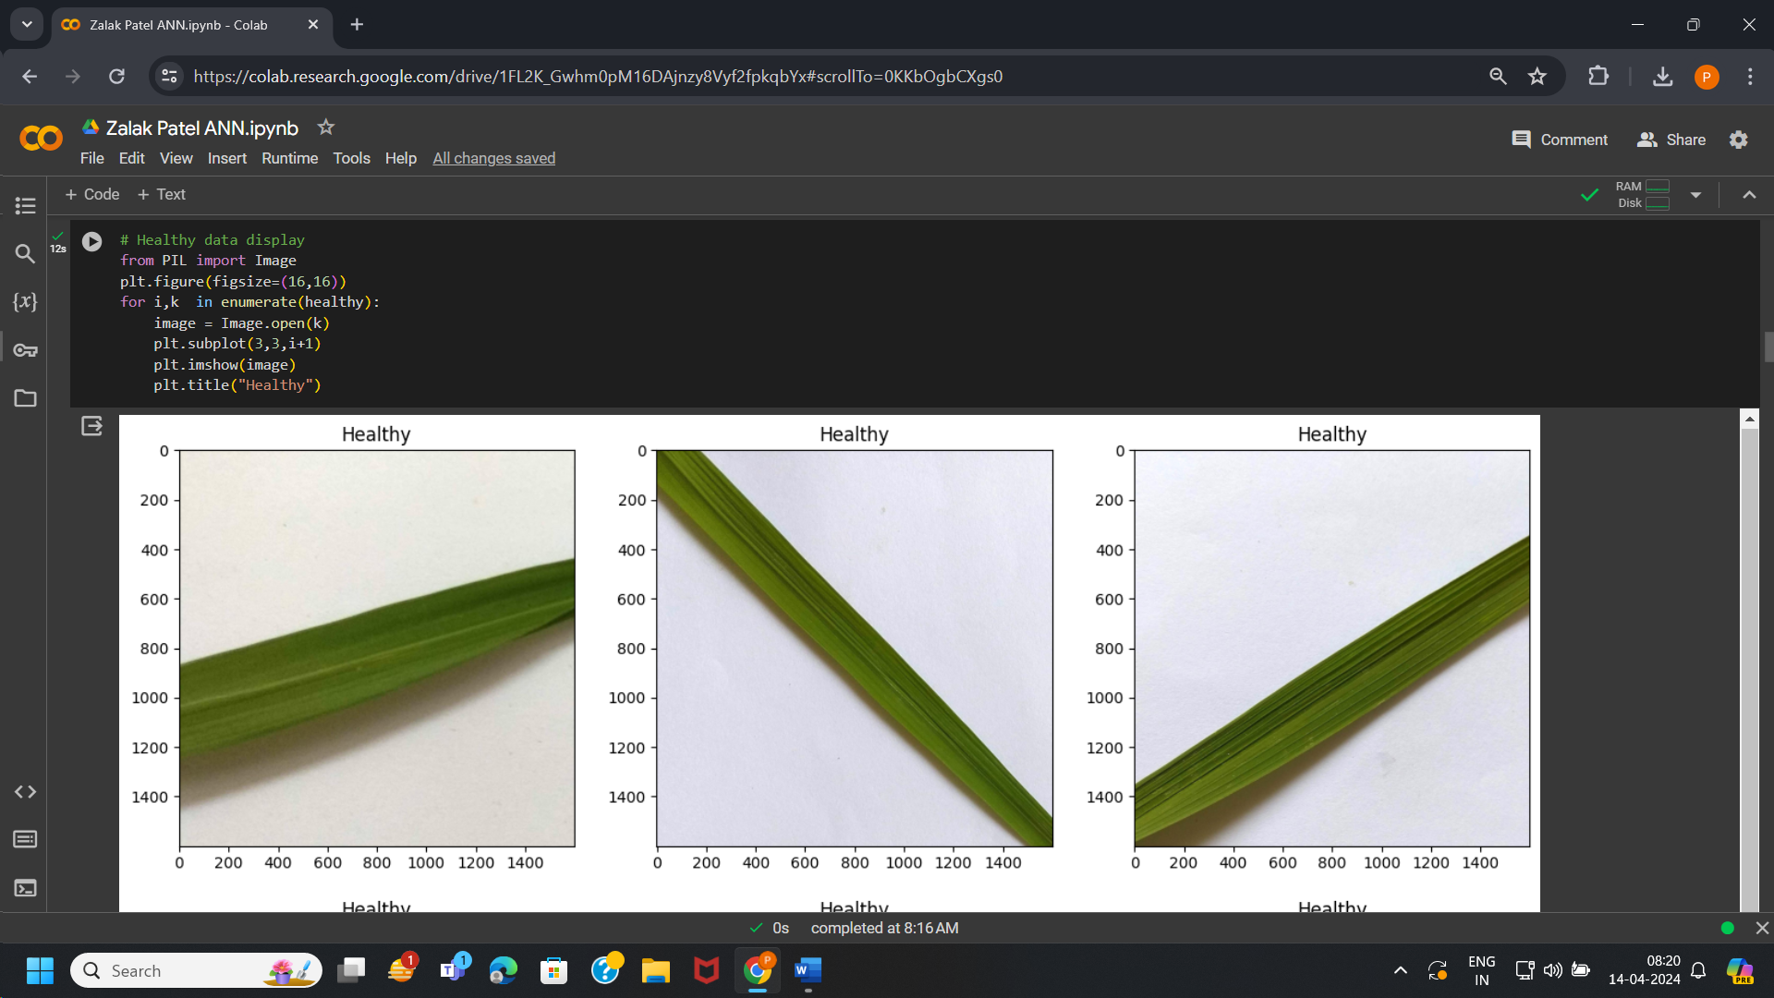

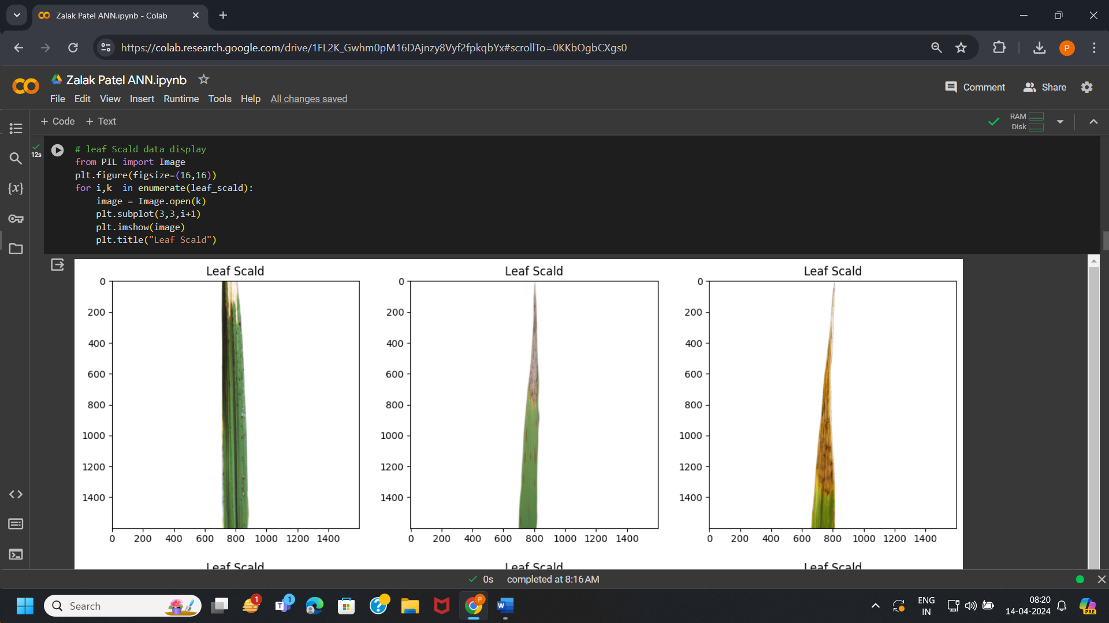

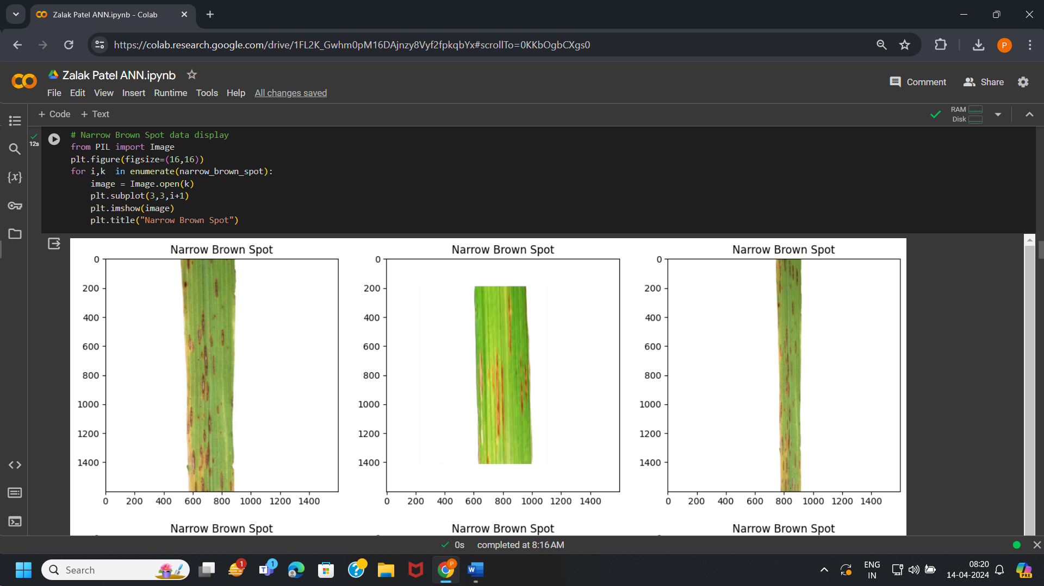

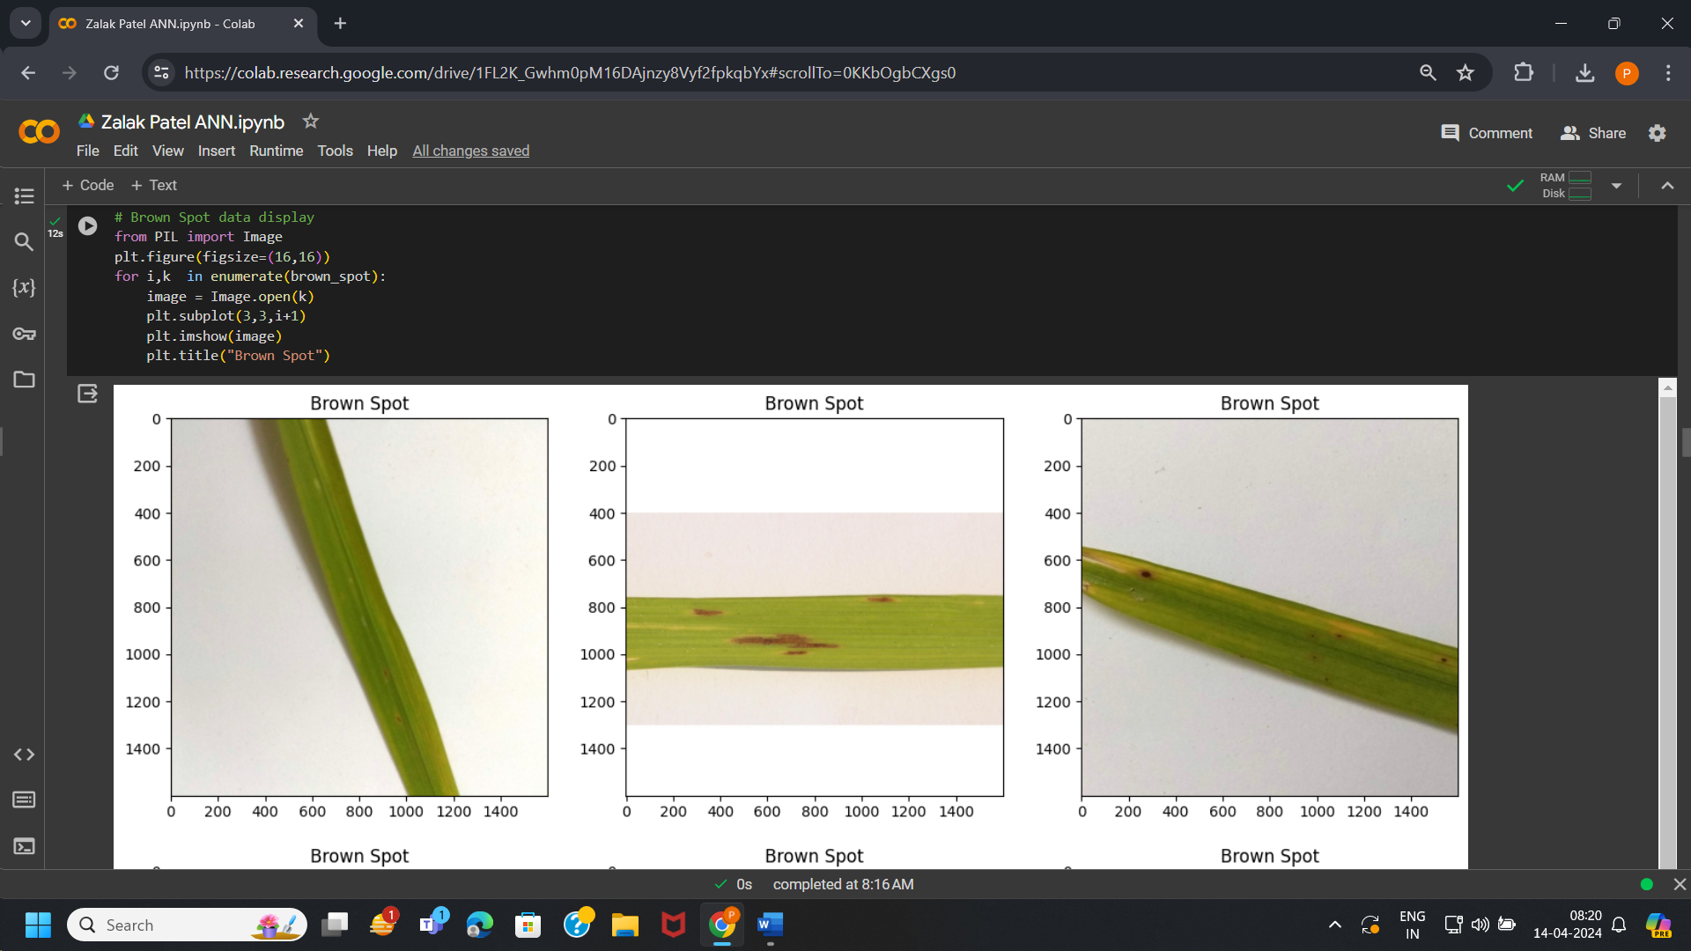

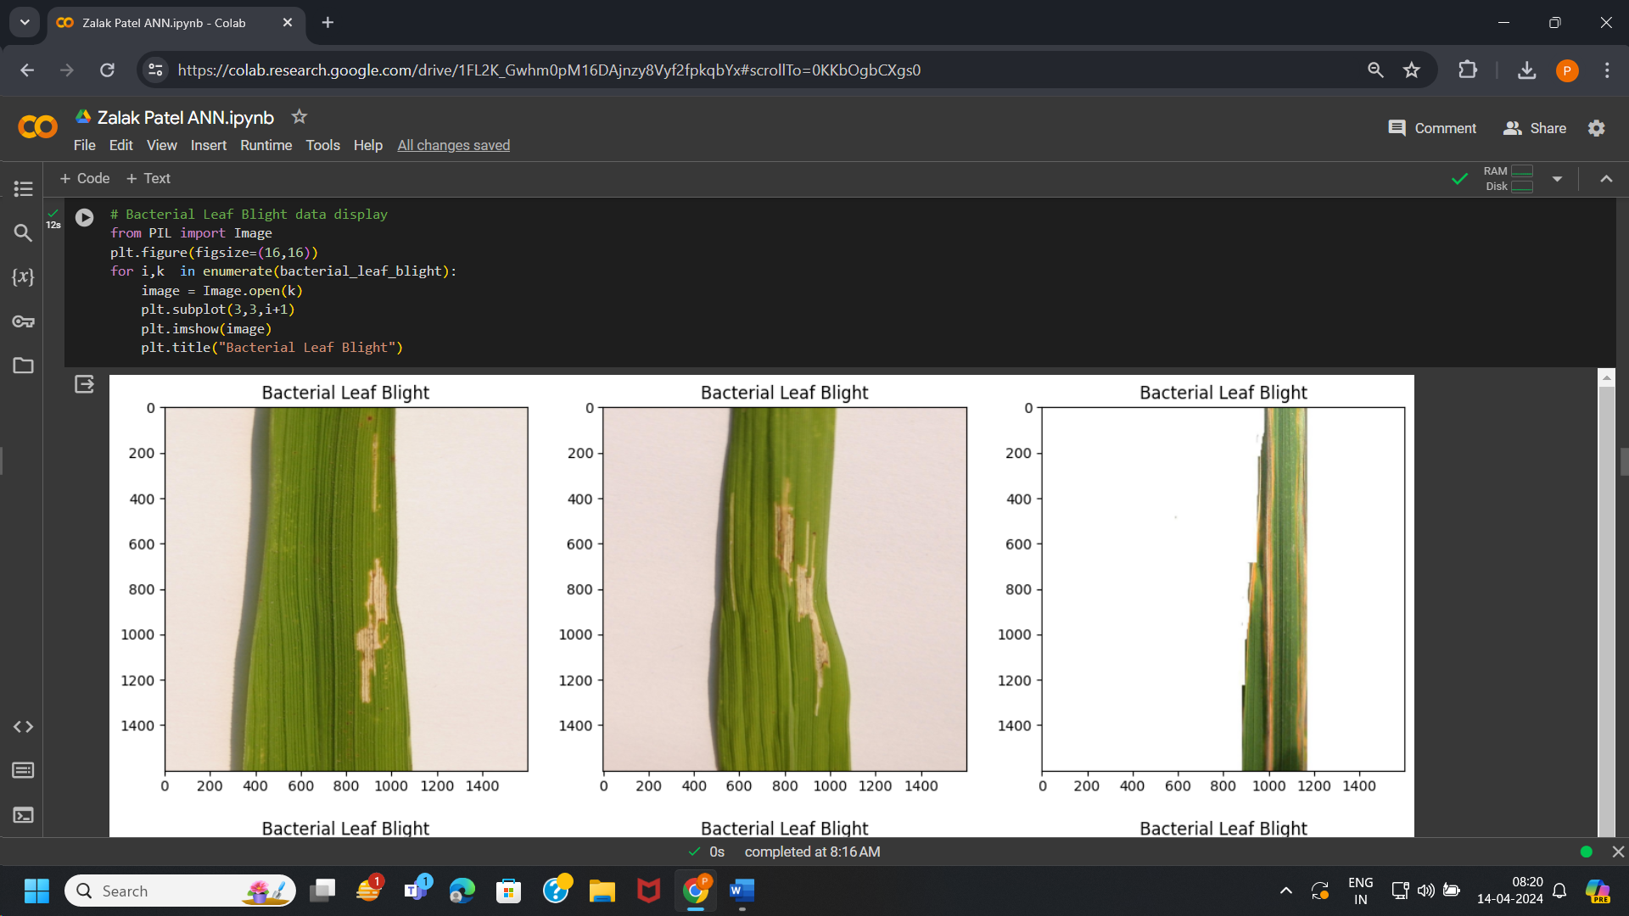

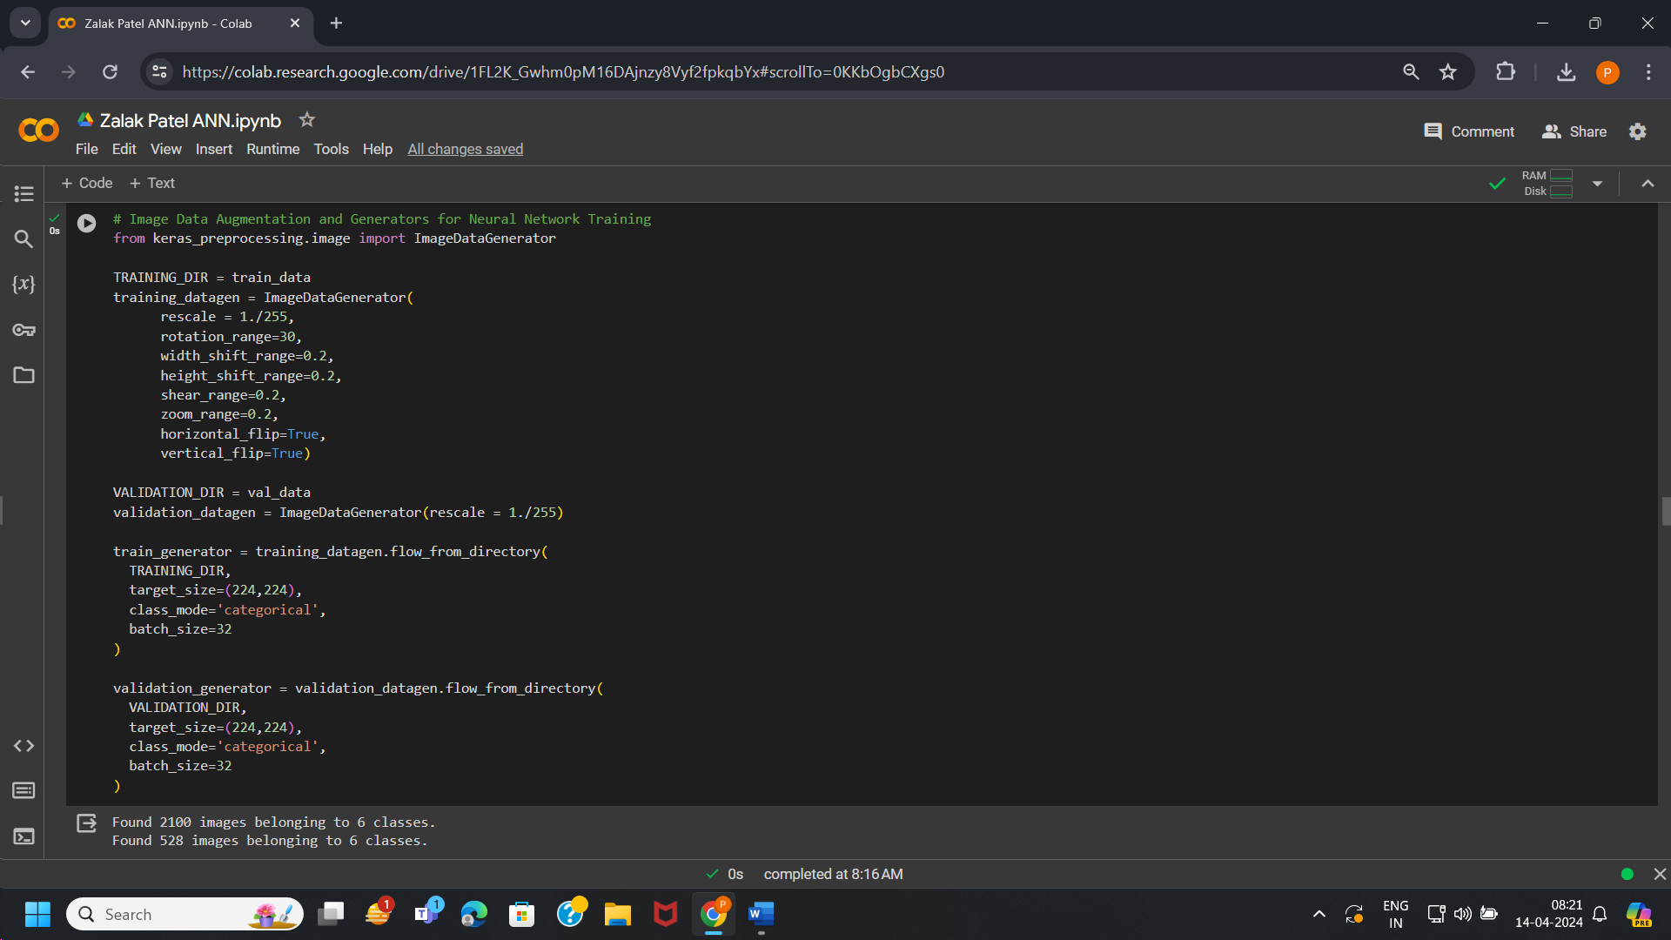

# MODEL ARCHITECTURE:

Convo2D layer, Maxpooling2D layer, Flatten layer, Dense layer are used in this project which includes 4 sequential layers of Convolutional Neural Networks (CNN).

Relu and softmax are the activation functions used in the model building process.

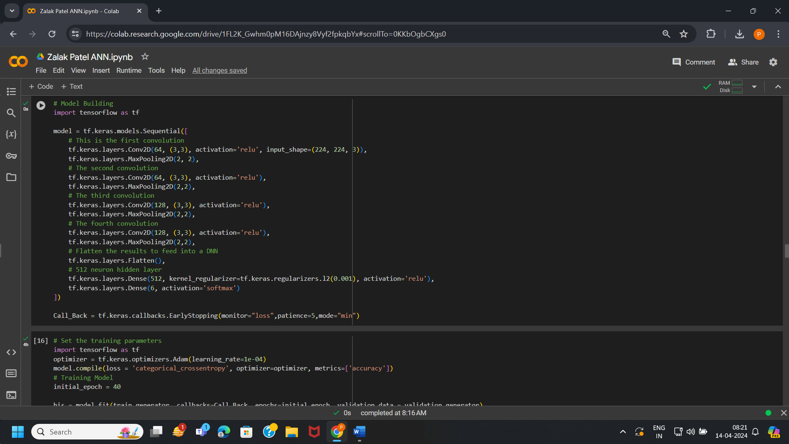

# TRAINING:

Model is trained with 40 epochs which shows training accuracy, loss and validation accuracy, loss. In this model we have approximately 88.43 % training accuracy, 40.21 % training loss, 89.02 % validation accuracy, 38.24 % validation loss.

Fine Tuning is used in pre-trained model which has large number of dataset. Training the model which can predict more enhanced accuracy we apply fine tuning. So, in the project we have applied fine tuning for 20 epochs which gives little difference in accuracy and loss of our model. Training accuracy and loss is 90.05 % and 33.67 % after fine tuning and Validation accuracy and loss is 91.67 % and 30.69 % after fine tuning.

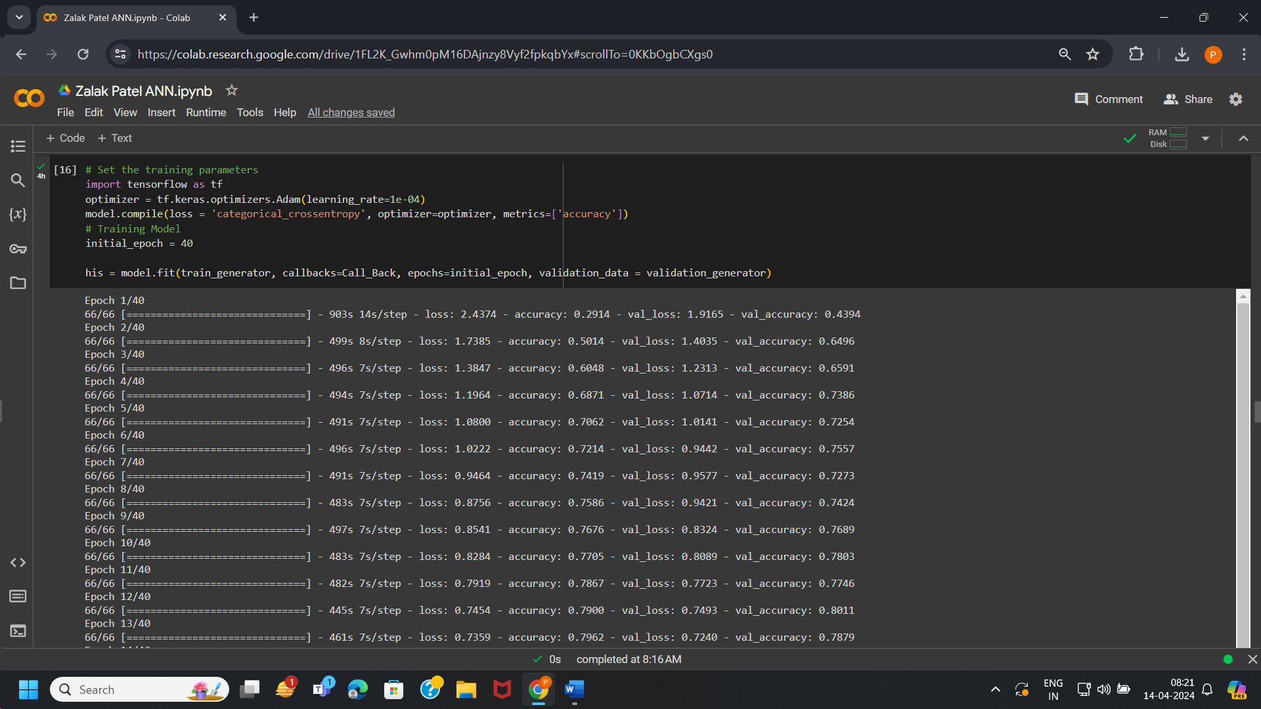

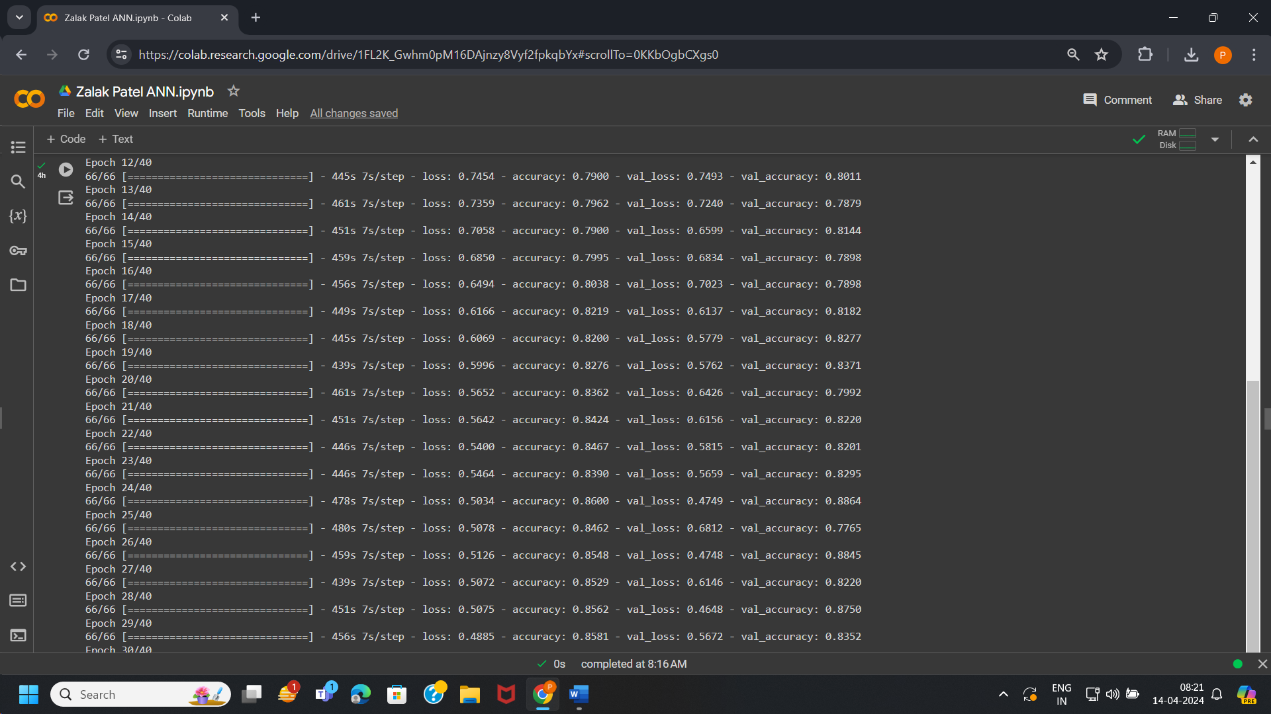

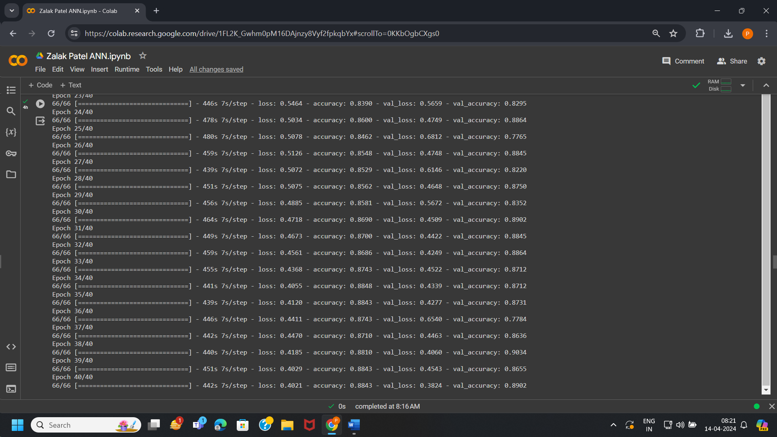

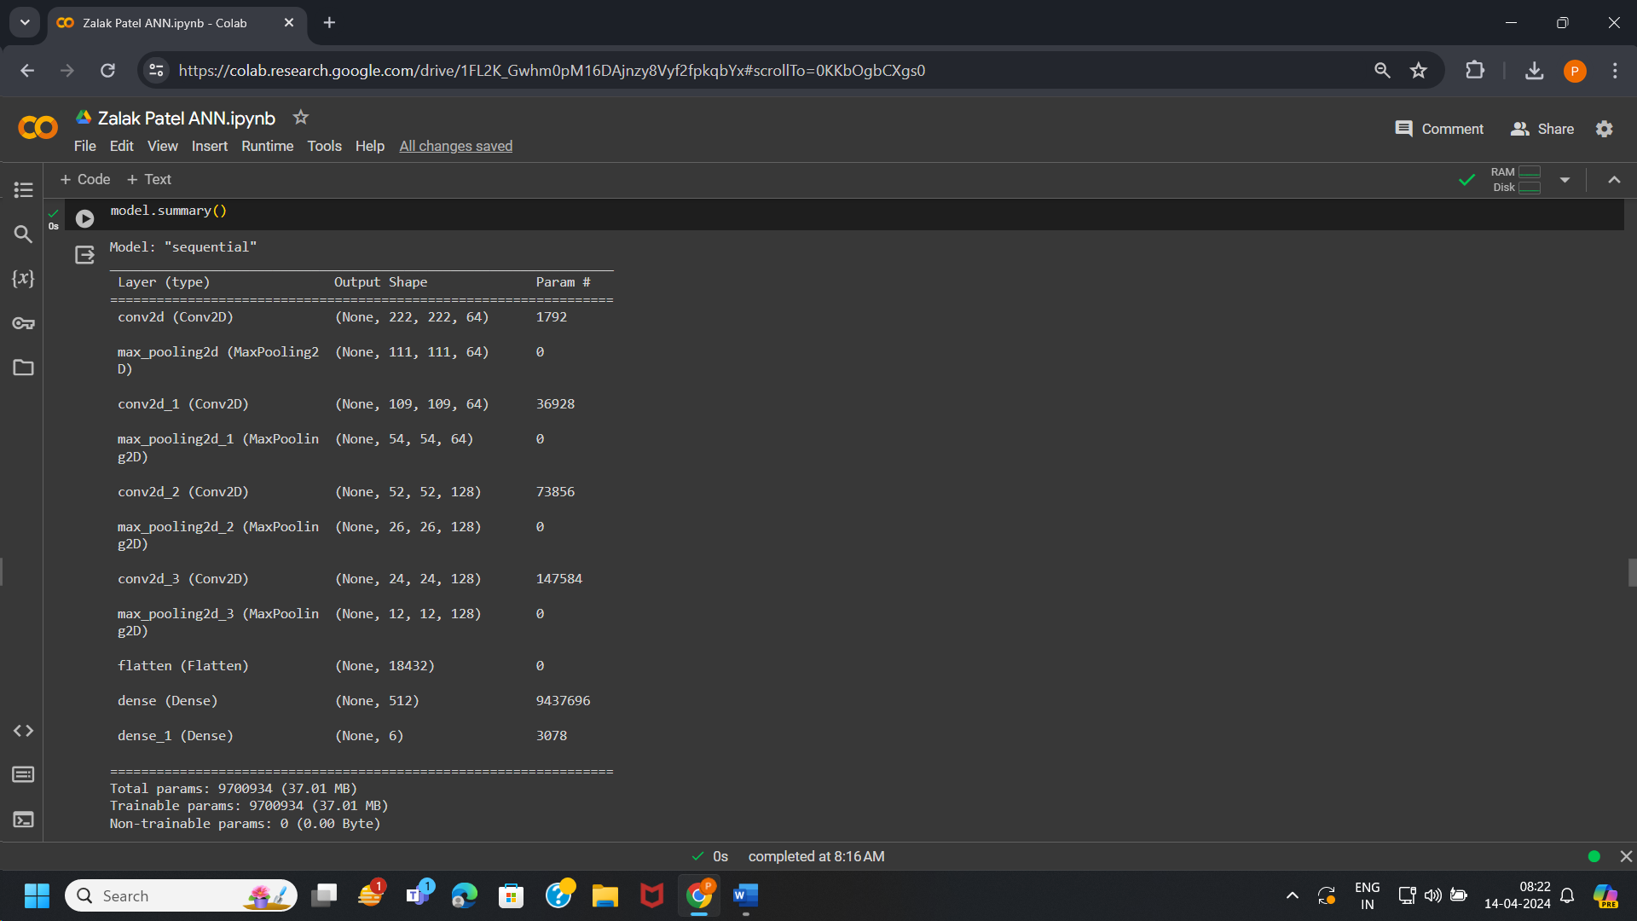

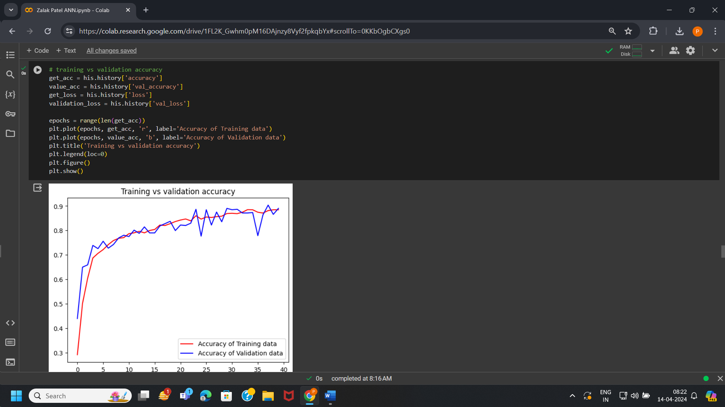

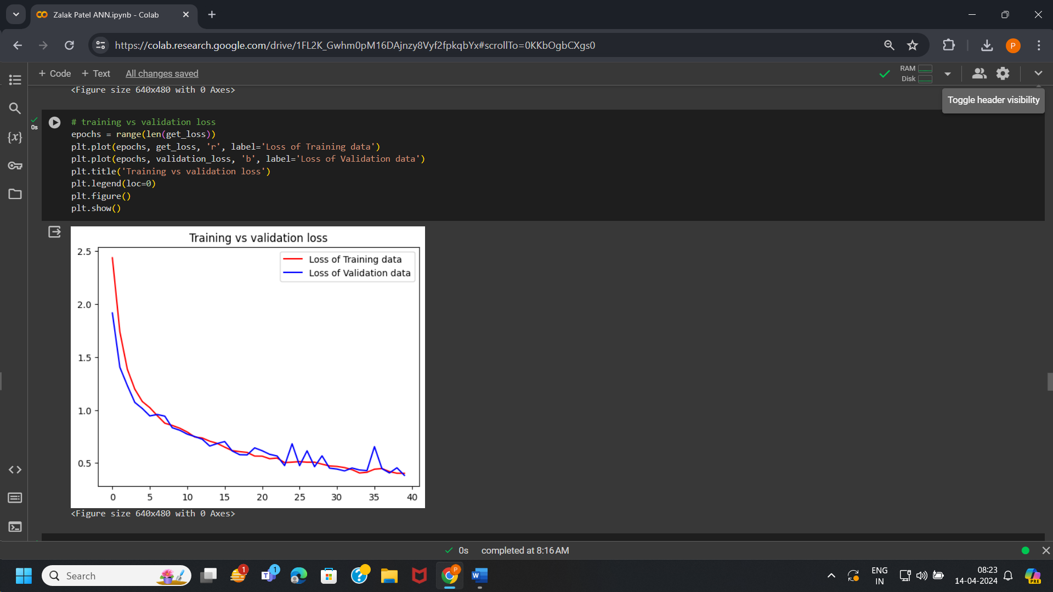

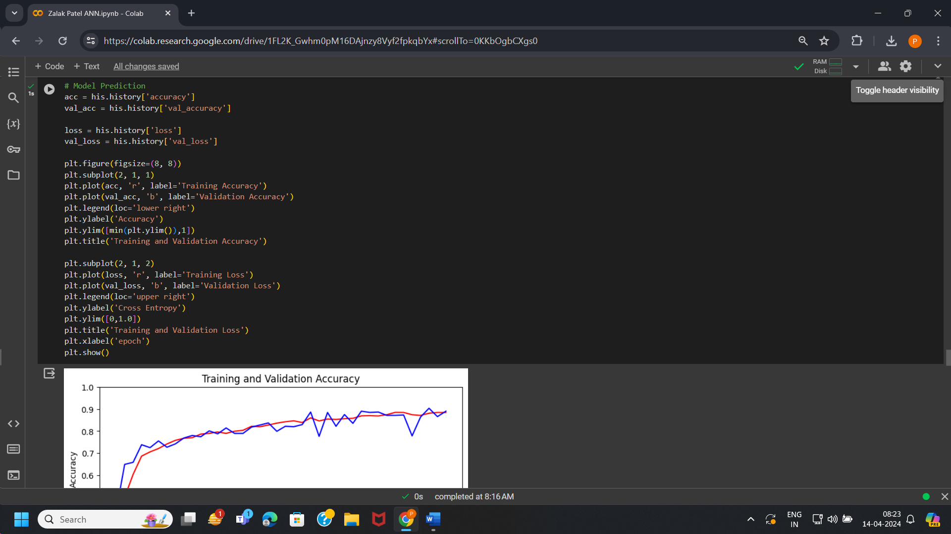

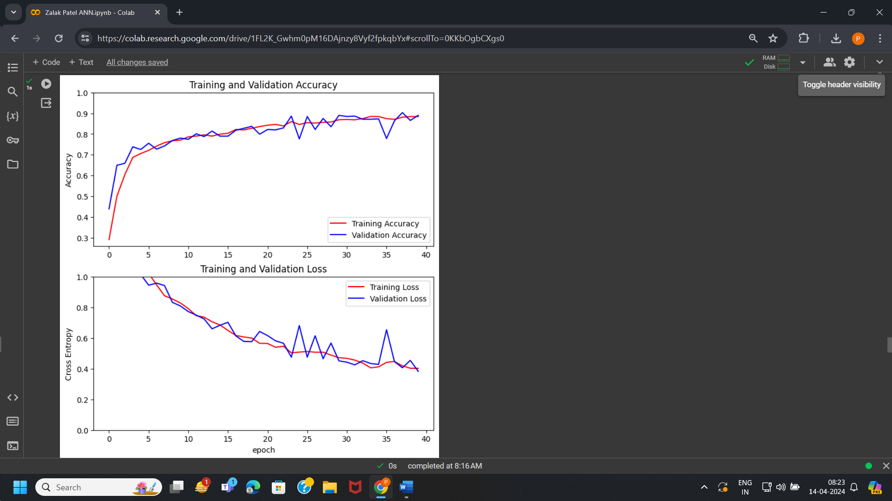

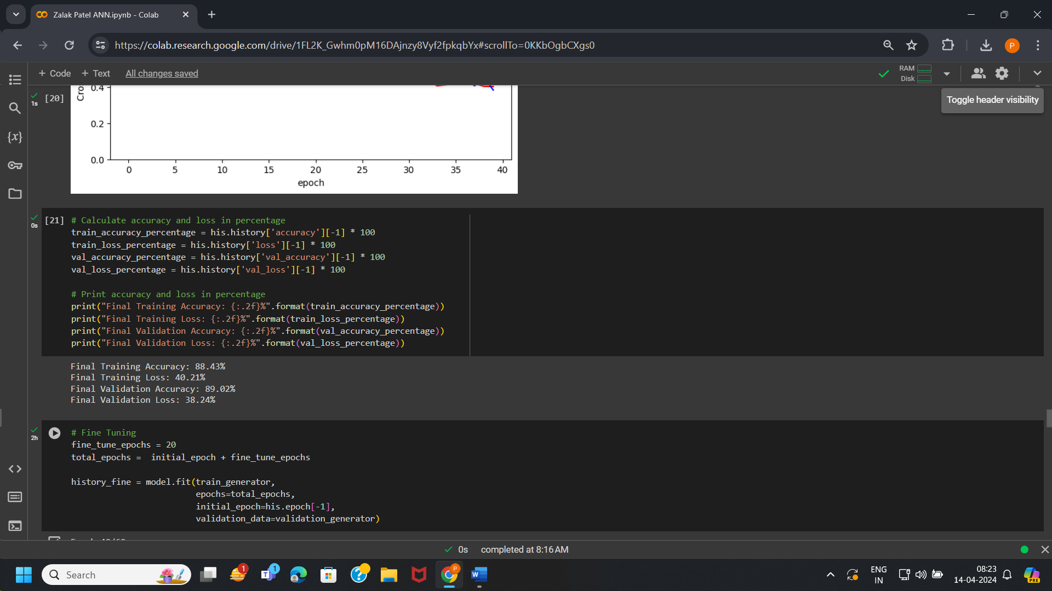

# FINE TUNING:

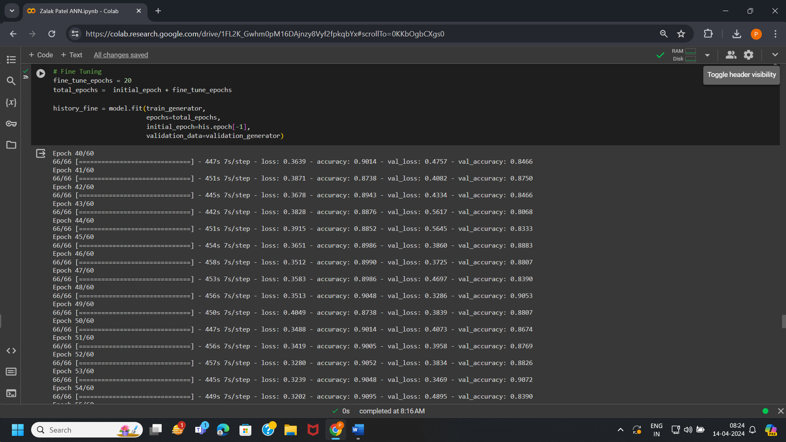

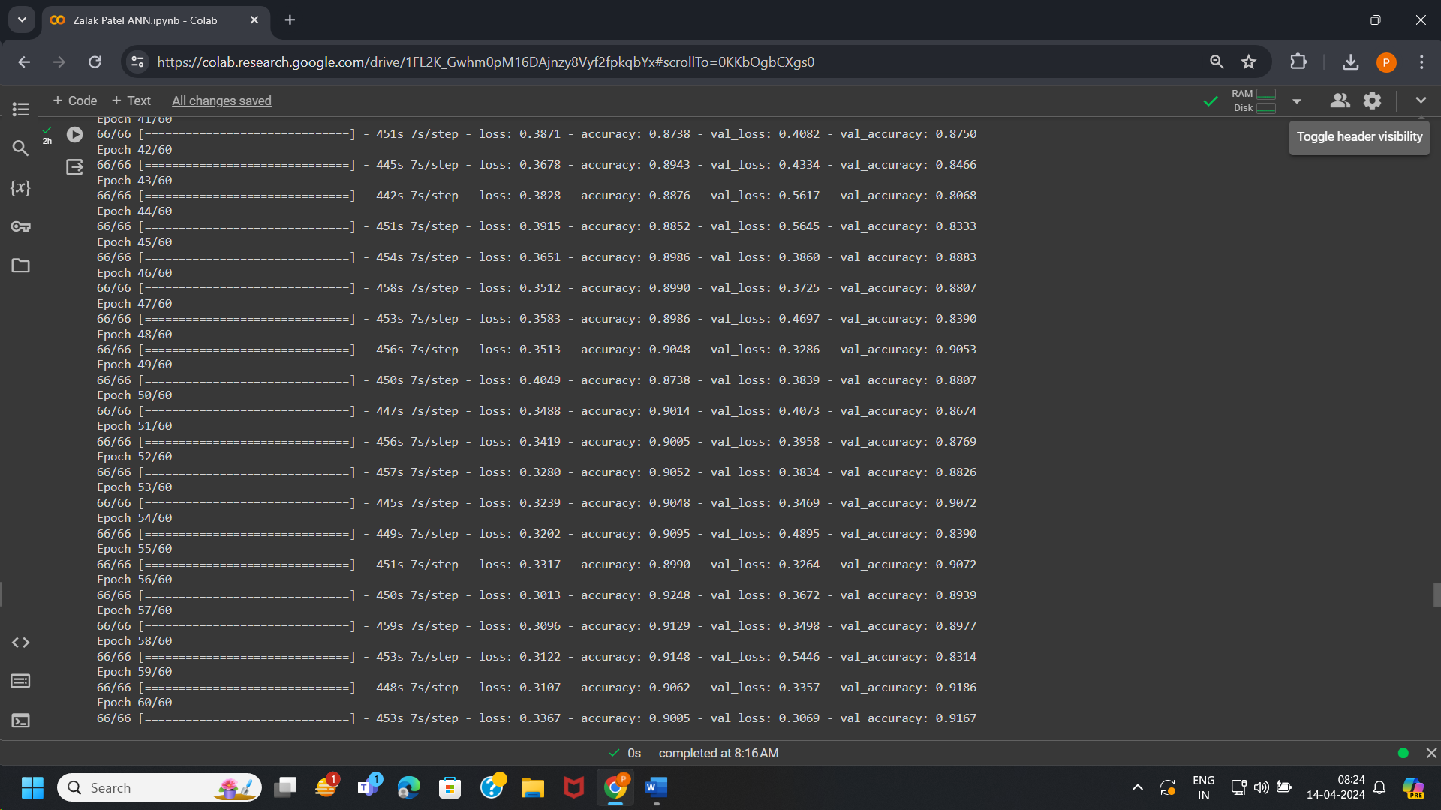

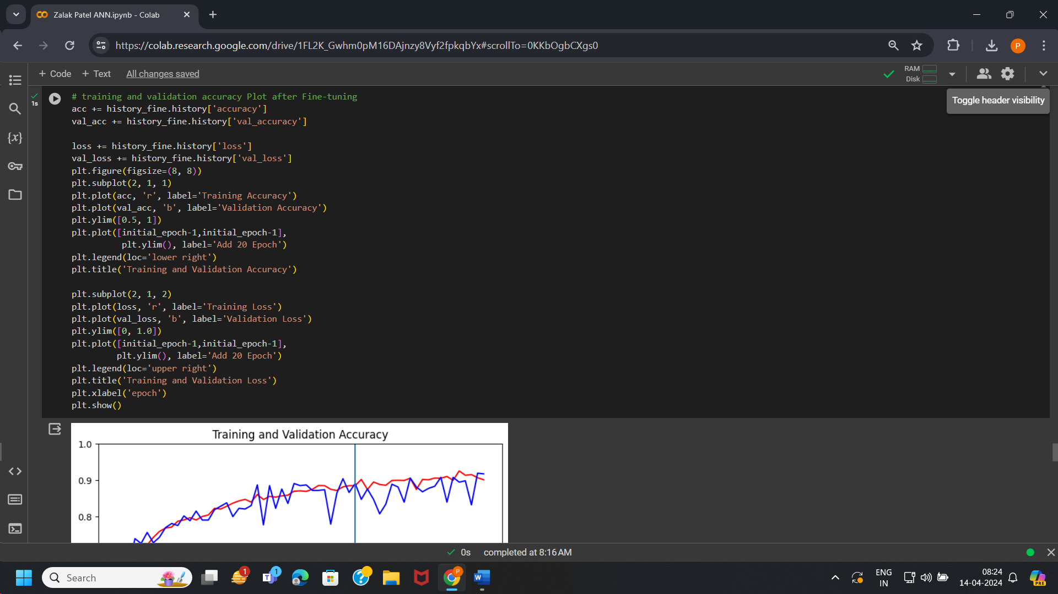

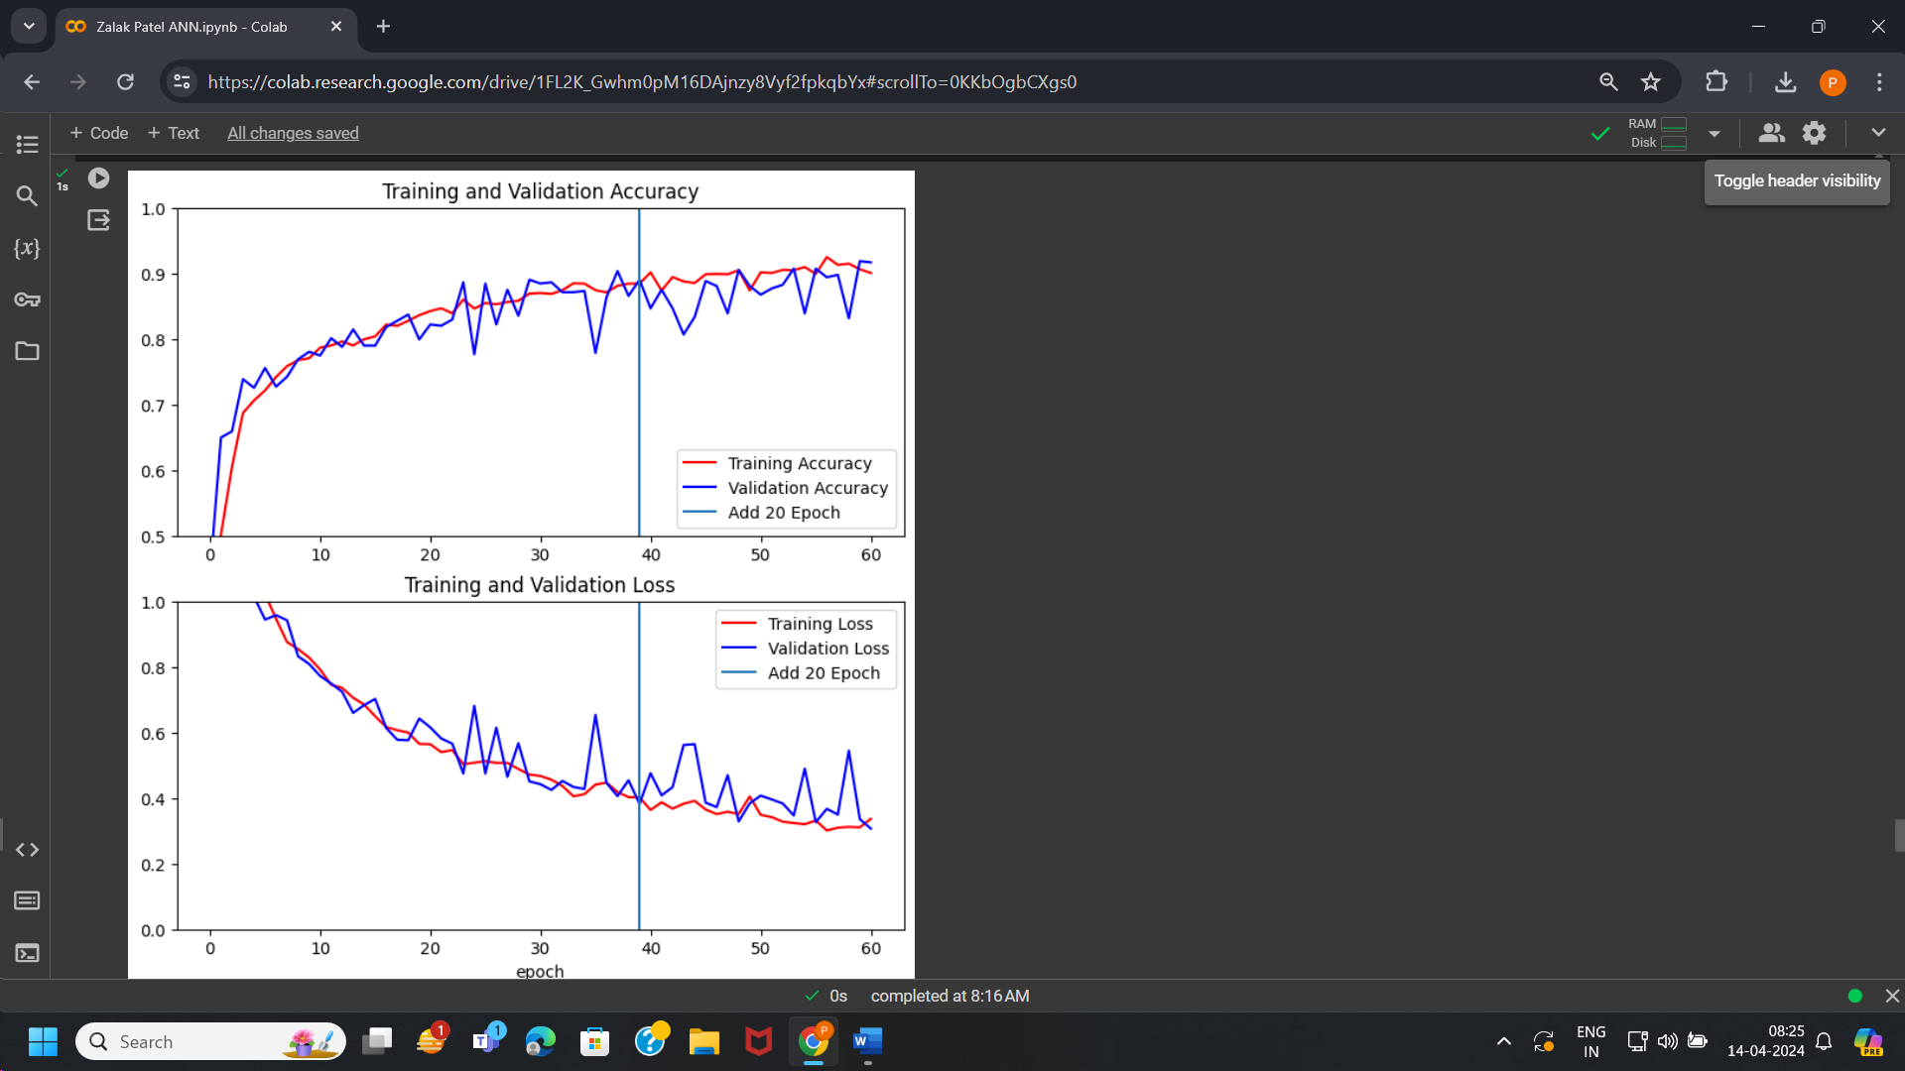

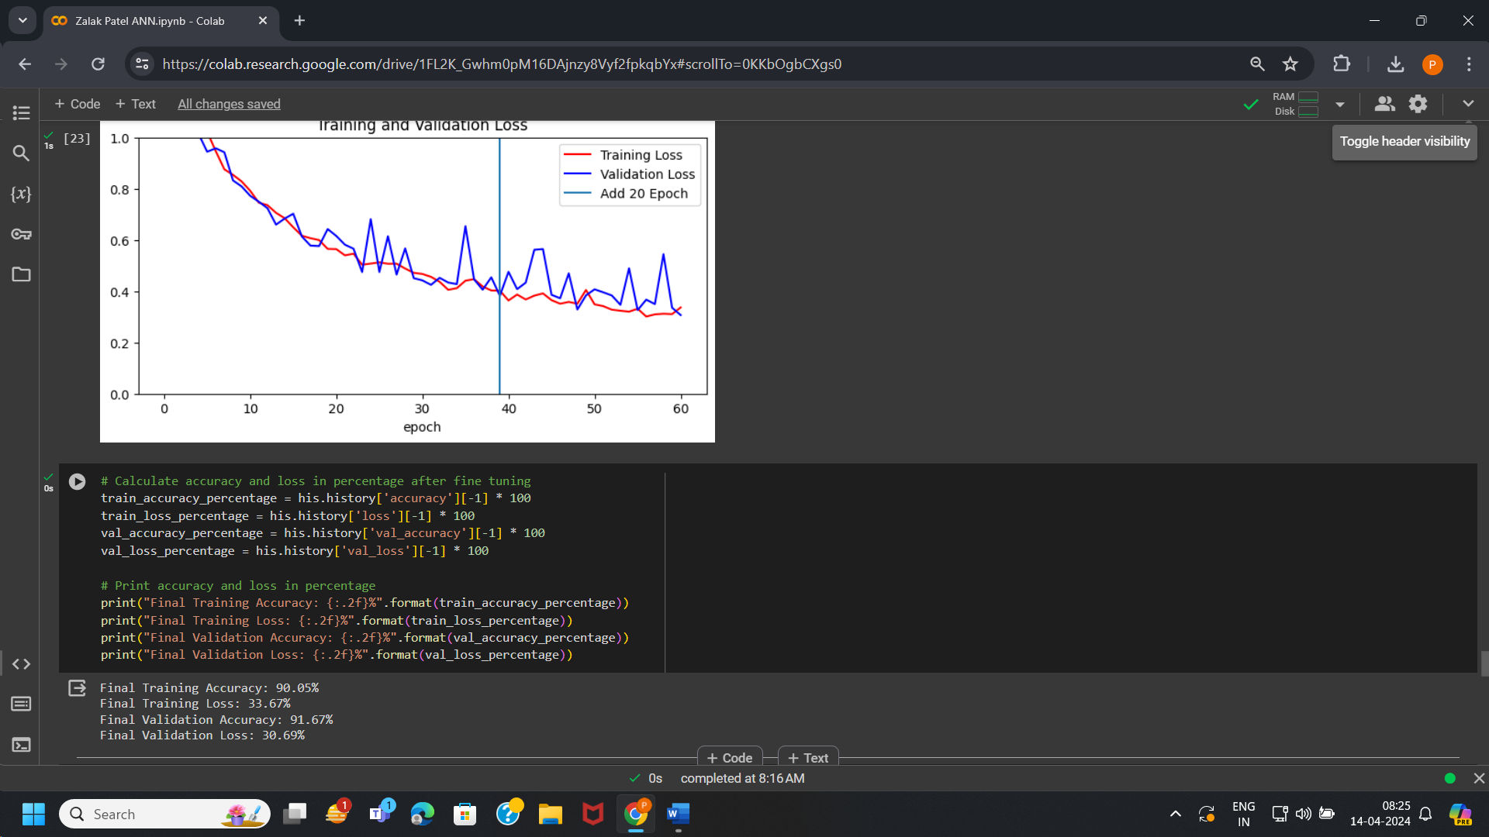

# PROJECT IMPLEMENTATION:

In this case, project implementation is done on unseen data from different test dataset on which our model is not trained. And model can predict successfully on unseen data.

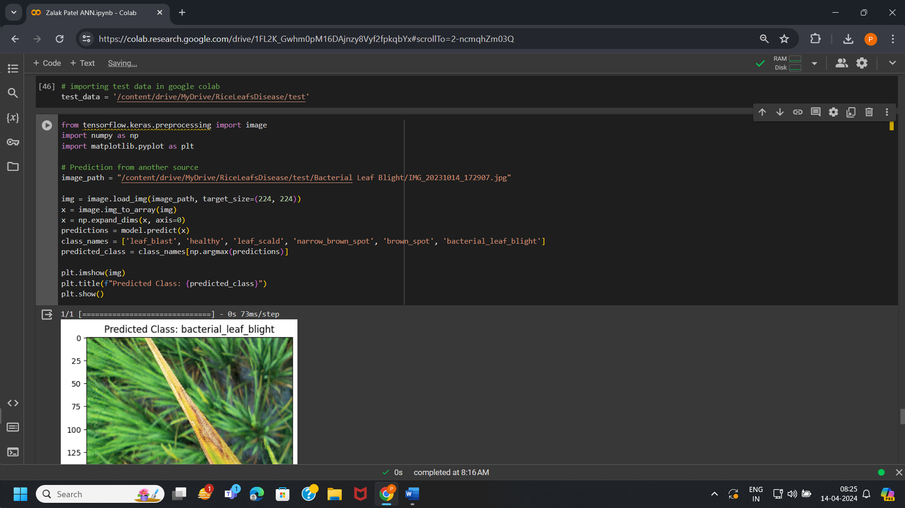

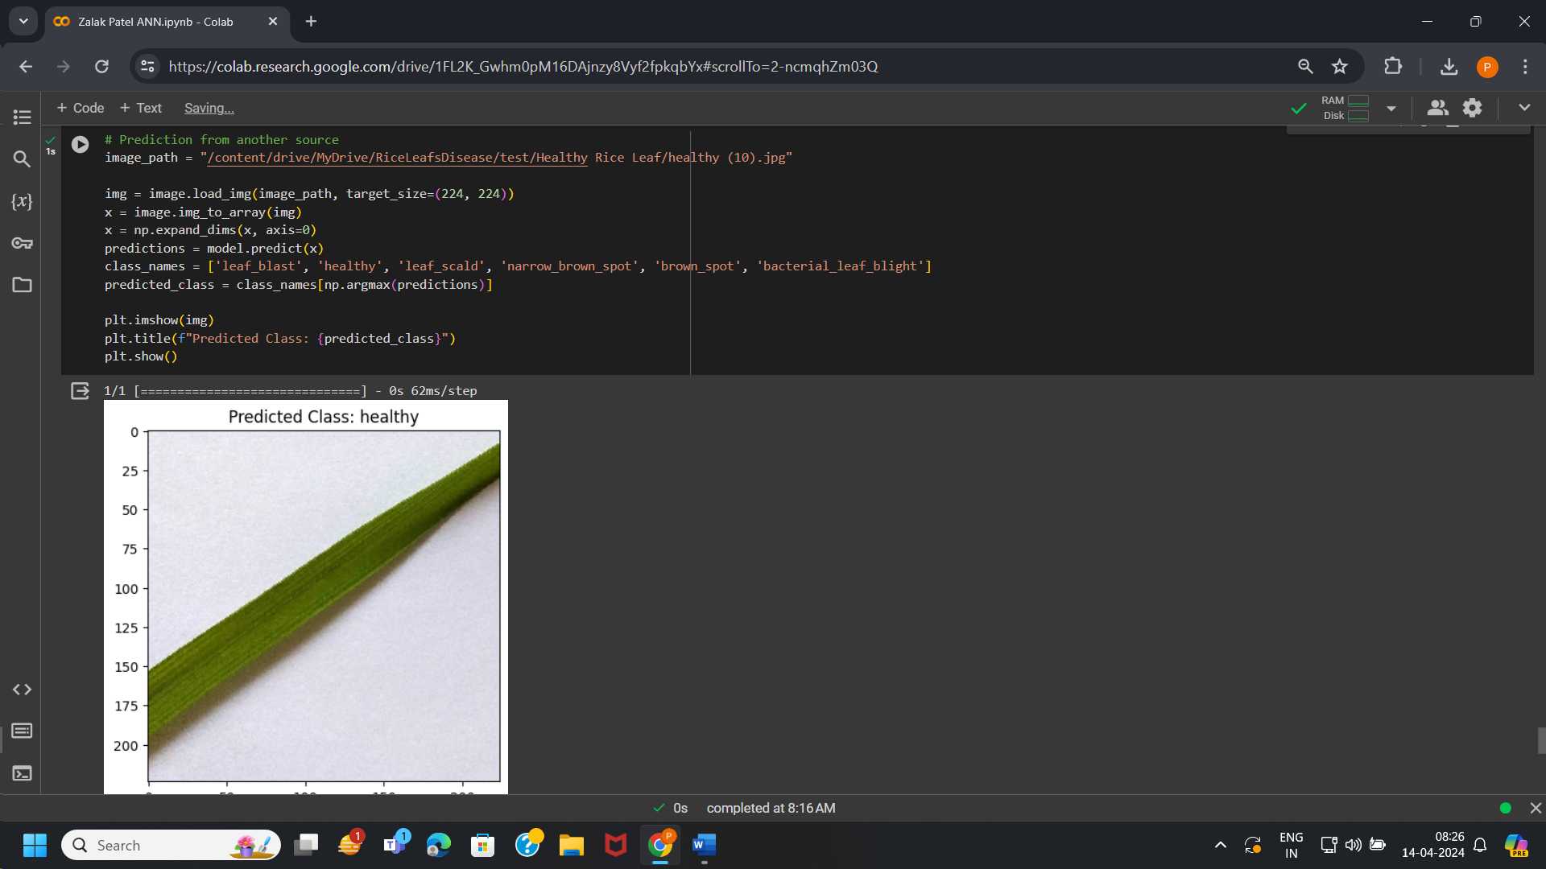

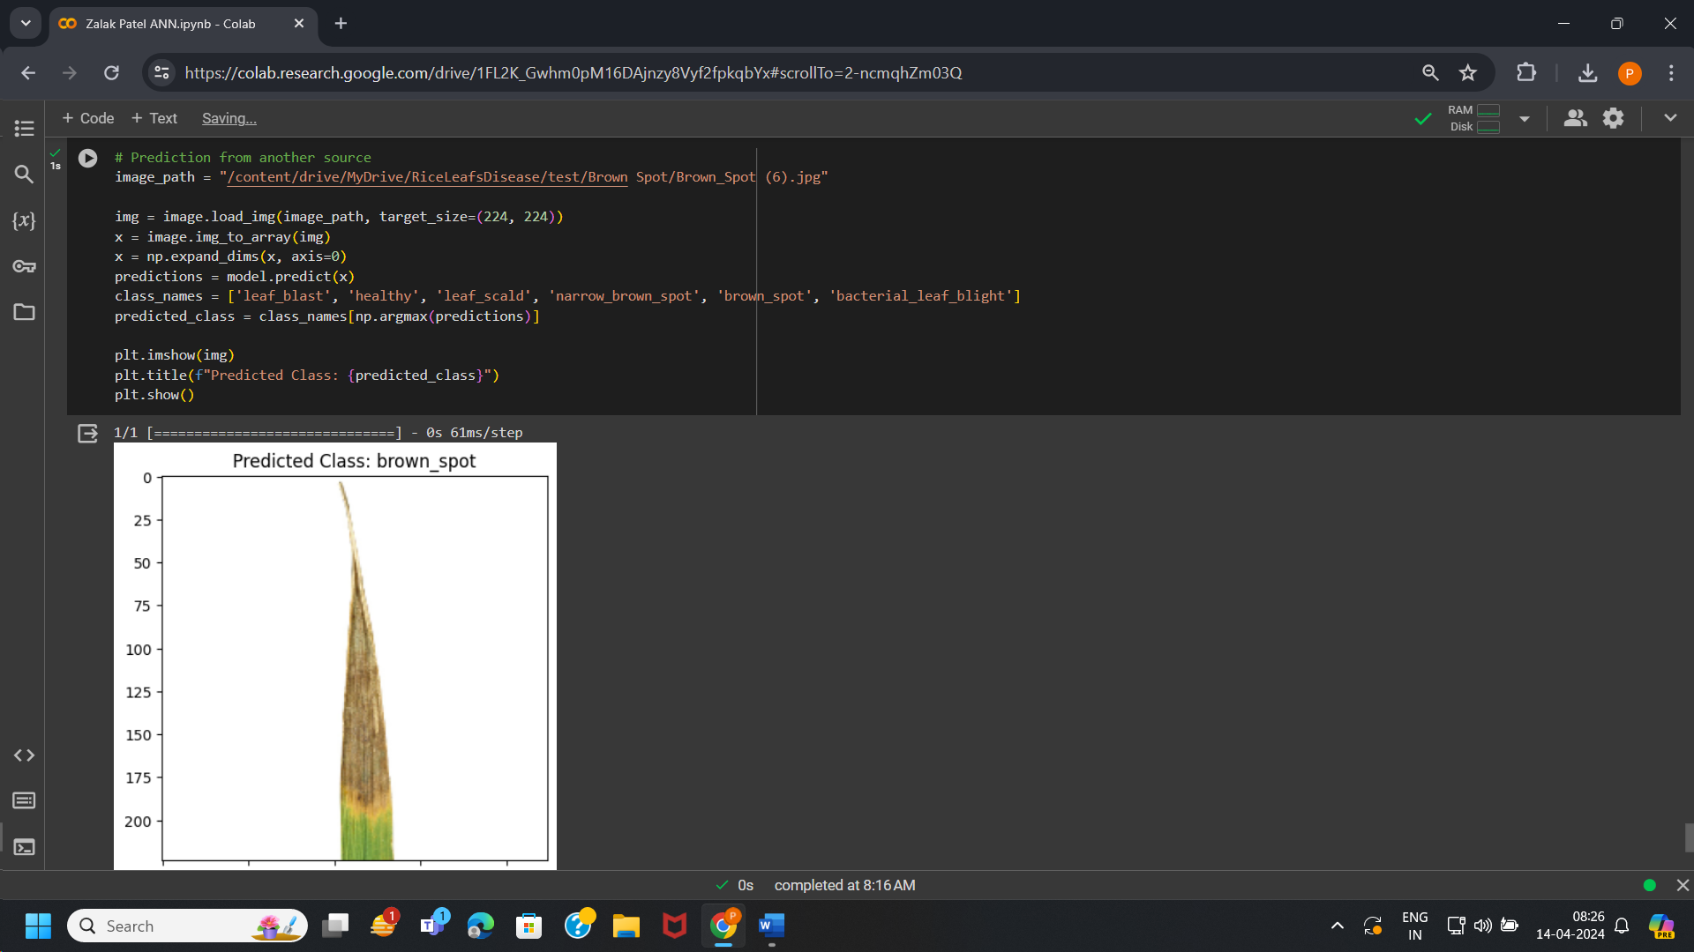

# CONCLUSION:

To Conclude, it is observed from the project that our model is accurate upto 91 % and can easily help farmers to detect diseases or infections in early stage of Rice leafs. This can prevent farmers from great loss and helps them make quantitative and qualitative production of Rice.